T-520-S
Drilling and Tapping Machining Center
Technical Agreement
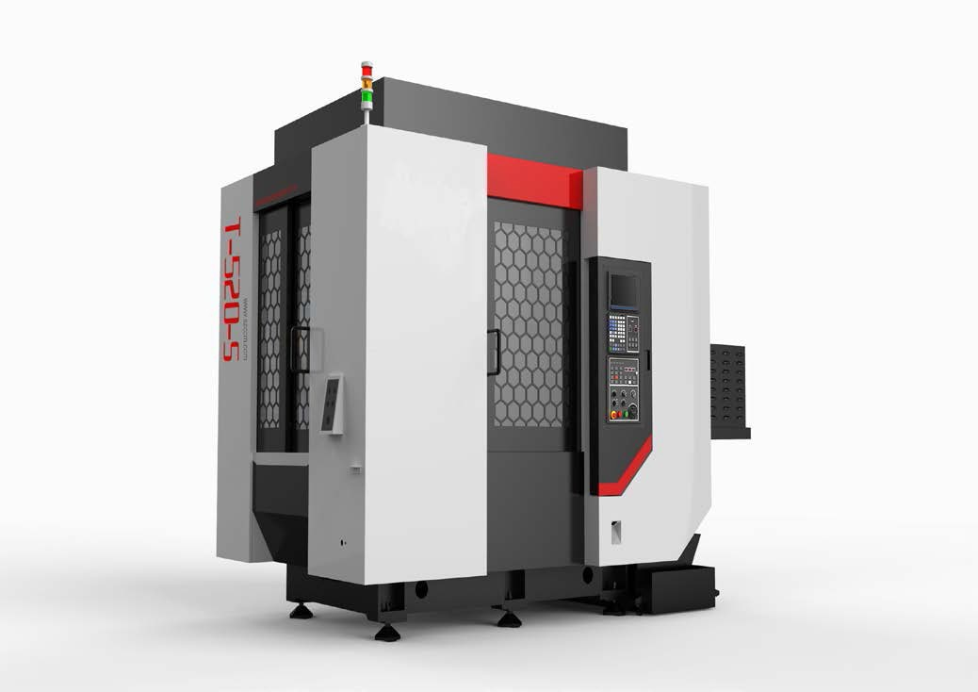
(This figure is for reference only)
- Technical description.
- Equipment technical description
T-520-S Drilling and Tapping Machining Center, the X, Y, Z three-axis screws all use precision ball screws, the three-axis guide rails use precision linear guide rails; the three axes use absolute servo motors; the spindle uses a precision-grade spindle. The direct-coupled transmission structure has a standard maximum speed of 20,000rpm; the cast iron adopts the Meehanite casting process and undergoes complete heat treatment to eliminate internal stress. The machine tool has high precision, high speed and high rigidity. It integrates drilling, tapping, milling and other processing. It is widely used in general industries, automotive parts, small mold processing, medical equipment and other industries for small plate parts and disk-shaped parts. Parts and shell processing.
- Through digital analysis and special design, the base structure has six-point super-span support, which improves the rigidity and vibration resistance of the machine and ensures good stability of the processing process.
- The spindle motor and spindle are directly driven to reduce errors in high-speed tapping, and the high output force characteristics can be greatly utilized in high-speed and efficient processing;
- The high-speed spindle has fast response speed and uses ceramic ball bearings, which greatly extends the service life of the spindle.
- Z-axis optimization improves stiffness and greatly increases Z-axis acceleration, reducing idle travel time.
- The machine tool has a large inclined chip removal angle, the machine tool removes chips quickly, and accelerates the return speed of the cutting fluid.
- High-speed servo tool change, PLC tool change optimal optimization, shorten tool change time, fast and stable, reduce non-processing time.
- Equipped with high-speed rigid tapping.
- By loading a high-speed PLC engine, the response speed is improved, the cycle is shortened, the processing detail parameters are optimized, the smoothness of the feed is improved, and the processing effect is improved;
- Working conditions
(1) Three-phase AC power supply: 380V±5%; 50Hz±1Hz, the main power cable, ground cable ≥6 mm²/10mm²;
(2) The ambient temperature: Keep the ambient temperature 17 ~ 25℃, if the precision of the machining parts is not high, it can be relaxed to 5 ~ 40℃. Storage or transport temperature -20 ~ 60℃. ;
(3) Room temperature change: the ambient temperature change within 24 hours is within ±2℃;
(4) Relative humidity: Less than 75% (no condensation);
(5）Altitude: Below 1000m;
(6) Vibration: Below 0.2G;
(7) Foundation requirements: bearing capacity above 32kN/m².
(8) Keep away from light sources, vibration sources and heat sources, as well as high-frequency generators, discharge motors, welding machines, etc., to avoid electrical interference that may cause machine tool NC system malfunctions.

2. Equipment parameters and configuration
2.1 Basic parameters
Item |  |  | Unit | Parameter | Remark
Travel | Table travel (X axis) |  | mm | 520
Travel | Saddle travel (Y axis) |  | mm | 340
Travel | Spindle box travel (Z axis) |  | mm | 350(21T)
Travel | Distance from spindle nose to work surface |  | mm | 205-555
Travel | Distance from spindle center to column guide surface |  | mm | 445
Workbench | Table size |  | mm | 620*1000 (double-sided)
Workbench | Max. load |  | kg | Single side 200
Workbench | T-slot (number of slots-slot width*spacing) |  | mm | 3-14*100
Workbench | Rotation diameter |  | mm | 1078
Workbench | Work piece height (including fixture) |  | mm | ≤300
Spindle | Motor power (rated/short time) |  | kW | 3.7/5.5
Spindle | Motor torque (rated/short time) |  | N.m | 14.1/21
Spindle | Spindle motor speed |  | r/min | 20-20000
Spindle | Spindle diameter |  | mm | Ф100
Spindle | Spindle taper |  | / | BT30
Guideway | X-axis guide rail specifications |  | / | 45
Guideway | Y-axis guide rail specifications |  | / | 45
Guideway | Z-axis guide rail specifications |  | / | 35
Drive | Screw specifications X, Y, Z |  | mm | X:40/12 Y:40/12  Z:32/12
Drive | Motor power X/Y/Z |  | kW | 2/2/2.2
Speed | Cutting feed speed range |  | mm/min | 1-15000
Speed | Rapid traverse speed (X/Y/Z) |  | m/min | 36/36/48
Accuracy | Positioning accuracy (X/Y/Z) |  | mm | 0.006 | GB/T18400.4 (total Travel)
Accuracy | Repeatability (X/Y/Z) |  | mm | 0.004 | GB/T18400.4 (total Travel)
Tool magazine | Tool storage capacity |  | T | 21
Tool magazine | Max. tool weight |  | kg | 3
Tool magazine | Max. tool length |  | mm | 200
Tool magazine | Max. tool diameter (full /adjacent empty) |  | mm | Ф60/Ф80
Other | CNC System |  |  | Mitsubishi M80VA
Other | Air supply | Flow | L/min | ≥200(ANR)
Other | Air supply | Air pressure | MPa | 0.6∼0.8
Other | Power capacity |  | KVA | 15
Other | Coolant tank capacity |  | L | 145
Other | Dimension (L*W*H) |  | mm | 3200*2090*2620 | Corresponds to X*Y*Z axis
Other | Weight (approx.) |  | kg | 5200
#: The overall dimensions of the machine tool may change due to configuration without further notice.

2.2 Customer chooses configuration
NO. | Item | Quantity | Remark
1
2
3

2.3 Equipment standard configuration
NO. | Item | Quantity | Remark
1 | Spindle motor 20000rpm | 1
2 | Direct-connected spindle 24000rpm
3 | 21T servo tool magazine | 1
4 | Centralized automatic lubrication system | 1
5 | Explosion-proof work light | 1
6 | Three color warning light | 1
7 | SD card/USB/RS232/network cable interface | 1
8 | Fully sealed outer cover sheet metal  protection | 1
9 | Pneumatic circuit system | 1
10 | Random set of standard technical documents | 1 | Electronic file
11 | Mitsubishi M80VA system | 1
12 | Pneumatic clamp solenoid valve | 2
13 | Safety door lock | 1 | Optional front automatic door, safety door lock cancelled

2.4. Requirements for processing workpieces
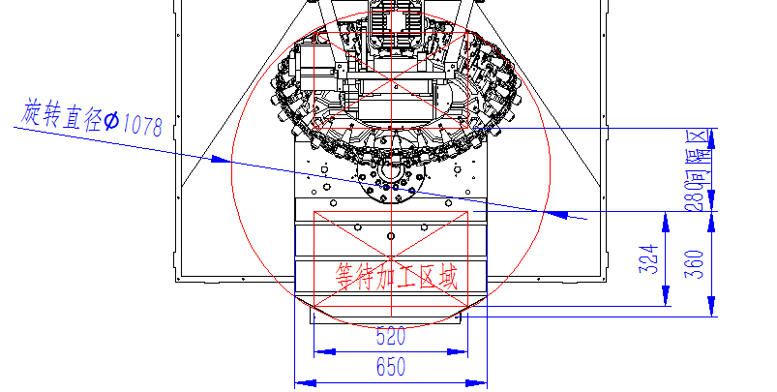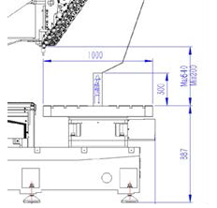
- The rotation time of the rotary worktable is 5 seconds. During the rotation of the worktable, it is prohibited to open the front door to perform any operation. The workpiece must be loaded and unloaded after the worktable stops positioning!
- The rotation diameter of the rotary table is 1078mm. The workpiece (including fixture) must not exceed the rotation diameter. The height of the workpiece to be processed (including fixture) is ≤300mm.
- The limit machining area is X*Y*Z = 520*360*300 (Note: The workpiece and fixture must not exceed the worktable surface).
- Only one person is allowed to operate, and it is prohibited for two or more people to operate and process at the same time. (For detailed operating instructions, please refer to the machine tool operating instructions)

- Brands of main parts of equipment
Main parts
No. | Part name | Brand | Remark
1 | Screw bearing | FAG/NSK | Germany/Japan
2 | Ball screw | PMI/ THK/NSK | Taiwan/Japan
3 | Spindle unit | Taikan(24000RPM)
4 | Tool magazine | Taikan
5 | Main pneumatic components | SMC/CKD
6 | Spindle servo motor | Mitsubishi (20000RPM) | Japan
7 | Three-axis drive servo motor | Mitsubishi | Japan
8 | CNC System | Mitsubishi M80VA | Japan
9 | Lubrication device | ZHENGHE/ BAOTN | Domestic
Note: In case of supply shortage, products of other brands will be used instead, but the quality and grade are not lower than the listed configuration.

- System main function table (some functions need to be combined with the configuration of the host to be realized)

No. | Function | Description | Remark
1 | Maximum Total Control Axes (Servo Axes + Spindle + PLC Axes) | 11
1 | Maximum Control Servo Axes | 9
1 | Maximum Control Spindle Axes | 4
2 | Simultaneous Control Axes | Maximum 4 Axes
3 | Display Unit | 8.4" Color LCD Screen
4 | Program Capacity | 2500KB (NC Storage + NC Storage 2)
5 | High-speed Machining Mode
6 | High-speed High-precision Control | Max 202 kBPM
7 | SSS Control
8 | Tolerance Control
9 | Minimum Instruction Unit | Can set the minimum instruction unit to 0.0001 mm
10 | Metric/Imperial Conversion | Conversion of machine units
11 | Decimal Point Input | Programming instruction data specification
12 | Positioning
13 | Linear Interpolation | Multi-axis or single-axis coordinated motion control
14 | Circular Interpolation | Circular machining function
15 | Spiral Interpolation | Spiral machining function
16 | Polar Coordinate Interpolation
17 | Polar Coordinates
18 | Automatic Acceleration and Deceleration Control
19 | High-speed Rigid Tapping | Reduces tapping time and errors
20 | Thread Time Constant Switch
21 | Manual Rapid Feed
22 | JOG Feed
23 | Incremental Feed
24 | Handwheel Feed
25 | Pause
26 | Background Editing | Program editing during machining
27 | Calculation Input
28 | Absolute/Incremental Setting | Programming instruction data specification
29 | Screensaver
30 | Parameter Wizard
31 | Alarm Wizard
32 | Screenshot
33 | Status, Clock, Operation, Editing, Maintenance Display
34 | Fault Diagnosis | View current machine faults
35 | Multi-language Display | Supports switching between multiple languages
36 | Program, Parameters, Tool Offsets Input/Output
37 | Multiple Connection Interfaces, Network, USB Transfer | USB (up to 32GB), etc.
38 | Digital, Analog Spindle Available
39 | Spindle Positioning | Stop spindle at a fixed point for tapping, tool change, etc.
40 | Spindle Synchronization Control
41 | Tool Offset Compensation | 400 groups
42 | Coordinate Systems | Basic: G52-G59, Extended 48
43 | Coordinate Rotation | Converts orthogonal coordinates for easier programming
44 | Plane Selection | Can select the required plane with G17, G18, G19 commands
45 | Reference Point Return 1, 2, 3, 4
46 | Skip Program Segments | Skip program segments for more flexible operations
47 | Single Program Segment | Execute program in segments instead of continuously
48 | Dry Run
49 | Mechanical Lock
50 | Auxiliary Function Lock
51 | Graphic Check
52 | Program Restart | Restart the program after temporary interruption
53 | Manual Insertion, MDI Insertion, etc. | Insert during operation
54 | Rigid Tapping Backstep | Can backtrack rigid tapping if interrupted
55 | Macro Program | Supports programming with variables
56 | Fixed Cycle for Drilling | Fixed cycle for hole processing like deep hole drilling
57 | Set, External Input Mirror | Achieve symmetrical machining via setting or external trigger
58 | Chamfering/Corner R at Any Angle | Chamfering/Corner R at any angle
59 | Drawing Dimension Input | Input dimension from the drawing for operations like chamfering
60 | Programmable Data Input | Input program data such as parameters, tool offsets
61 | Automatic Corner Scaling | Automatic scaling for corner machining
62 | Deceleration Check | Check deceleration stop position
63 | Programming Wizard
64 | Pitch, Backlash Compensation | Machine axis pitch and backlash compensation
65 | Arc Radius Error Compensation
66 | Dynamic Accuracy Compensation | Smooth high gain, dual feedback (closed-loop)
67 | Tool Life Management 1 | Tool usage monitoring
68 | Tool Life Management 2 | Extended tool life management
69 | Tool Life Management Quantity | 200 tools
70 | Machine Group Alarm Stop
71 | User-Level Data Protection
72 | Stroke Protection
73 | Interlock
74 | Operation History, Data Backup
75 | Custom API Library
76 | MES Interface Library
77 | Power Consumption Calculation
78 | PLC Position Switch | PLC function, designed for specific use
79 | PLC Servo Shutdown
80 | PLC Axis Removal
81 | Wireless Network (WiFi)
82 | Cutting Load Control
83 | Operation History Display
84 | Extended Variables III
85 | PLC Supports ST Language
86 | High-precision Parameter Adjustment
87 | OMR-CC
88 | Drilling Chip Removal Function
89 | Fixed Cutting Reduction for Drilling
90 | Spline Curve Interpolation 2 (G61.4) | Supports parameter control
91 | Multi-instruction for Tilted Surface Machining (G68.4)
92 | Mechanical Rotational Center Error Measurement
93 | Mechanical Rotational Center Error Compensation
94 | QR Code Machining Cycle
95 | Laser Machining Control | Requires laser interface module
Special Note: For more details on available functions, please refer to the M80V series specification guide. Due to machine configuration changes and design differences, please confirm the order based on the agreement.

- Recommended oil and grease table (refer to this table according to the actual configuration of the equipment)
Lubricating Part |  | Quantity | Recommended Oil |  | Remarks
 |  | Quantity | Room temperature 10-40℃ | Room temperature 5-10℃ | Remarks
Guide rail screw | Oil lubrication | 2-4 L | Guide rail oil 68# | Guide rail oil 32# | 1. Please add oil when checking before daily work or when the warning appears.  2. Pay attention to changing oil at low temperature.  3. When using canned grease, the brand of canned grease must be consistent with the manufacturer of the oiler.
Guide rail screw | Oil lubrication | 0.7-0.8L | Lithium base grease 000#
Spindle screw cooler | Coolant cooler | 15-35L | BASF G48 antifreeze (no addition of any medium is allowed)） |  | 1. Please add antifreeze or oil when checking before daily work or when the warning appears.  2. Please change the oil at low temperature.
Spindle screw cooler | Oil Cooler | 20-40L | No. 10 Great Wall Spindle Oil | No. 5 Great Wall Spindle Oil
Motorized spindle | Oil and air lubrication | 2-4L | ENEOS SUPER MULPUS DX32 (Brand: VG32) |  | Please refuel during daily pre-work inspection or when a warning message appears.
Hydraulic station |  | 25-40L | Hydraulic oil HV32# | Hydraulic oil HV20# | 1. Check before work every day and replace with new oil every year.  2. Pay attention to replacing oil at low temperatures.
Booster cylinder |  | 0.1-0.2L | Hydraulic oil 32# | Hydraulic oil 20# | 1. Check before work every day, and add oil when the oil cup is only 1/3 full.  2. Pay attention to changing oil at low temperature
Cutting fluid |  | 100-400L | According to the workpiece material and processing conditions, select the appropriate cutting fluid (based on the actual tank capacity) |  | When the room temperature is below 5℃, please check whether the fuel tank is frozen before starting the machine.
Fourth axis |  | 0.8-1L | Gear Oil 150# | Gear Oil 100# | 1. Check before work every day and replace the oil every six months.  2. Pay attention to replace the oil at low temperatures.
Tool changer arm system |  | 7 L | Gear Oil 100# | 80W-90 Antifreeze diesel engine oil | 1. Check before work every day, and replace the oil every 2400 working hours or every six months.  2. Pay attention to replace the oil at low temperatures.
Requirements:
A. The coolant must be water-soluble;
B. The coolant must be chemically stable and have lubricating properties;
C. Ensure that the coolant is not toxic to the human body;
D. Ensure that the coolant does not harden or swell items made of rubber and resin;
E. Use low-foam coolant;
F. If cutting fluid (oil) is not used for a long time, the protective cover needs to be maintained regularly.

- Others
1. Matters not covered in this agreement shall be resolved through negotiation between the two parties.
2. This agreement is an attachment to the contract and will take effect simultaneously with the contract after being signed by Party A and Party B.
3. This agreement is made in duplicate, with Party A and Party B each holding one copy.

